**CHANEL S/S 2022 Ready-to-Wear collection** returned to the Grand Palais. The show without magnificent props put emphasis on the release of clothing. Inspired by the magic of fashion seen through the photographer’s lens, the CHANEL Spring-Summer 2022 Ready-to-Wear show evokes the heightened emotions and memories of the raised runways of the 1980s surrounded by photographers and flashbulbs. **Romantic with a touch of mystery**, the collection balances the graphic purity of black and white, playful summer stripes, and the dark whimsy of a butterfly’s wings on black chiffon. Behind the camera lens, model Vivienne Rohner plays the role of both photographer and fashion muse in cinematic black and white, for a first glimpse of the inspirations behind the collection by Virginie Viard.

**Bright colors were the mainstream of this ready-to-wear show**, which was not a stranger to CHANEL, because Karl Lagerfeld often applied these tones in the late 80s and 90s. It could be the exclusive memory for CHANEL in that period.

While the Grand Palais, scene of so many elaborately staged Chanel spectaculars, undergoes an epic renovation (generously underwritten by Chanel), this collection was presented in a temporary space, set up in the shadow of Les Invalides, which allowed Viard to recapture the memory of the shows she had thrilled to when she was a fashion neophyte.

Virginie Viard woven the brand DNA of CHANEL into the motif this season. Double-C was integrated into jacquard, obscure motif, yarn-dye and sequin to form fabrics. Besides, the logo is rather important to the luxury market, and this essence of the brand creates ready-to-wear with high recognition.

To recreate the infectious runway energy, **Chanel elevated the catwalk at the Grand Palais Éphémère**, where the photographers would flood the surrounding sides for the perfect shot at the start of the show, synonymous with the late ’80s and early ’90s.

The event was quite successful with an appealing and interesting presentation which made it the talk of the town.

The perfect placing of the photographers to get beautiful and meaningful images was a really efficient move to capture the essence of the collection.

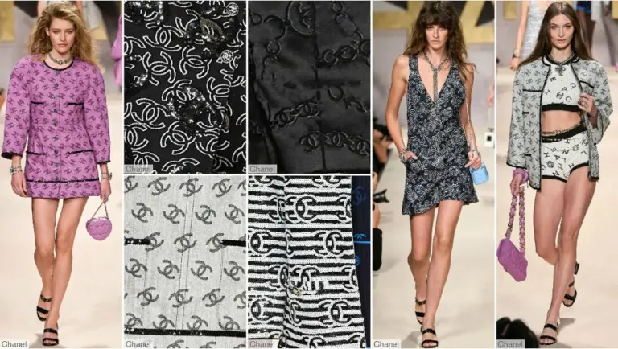

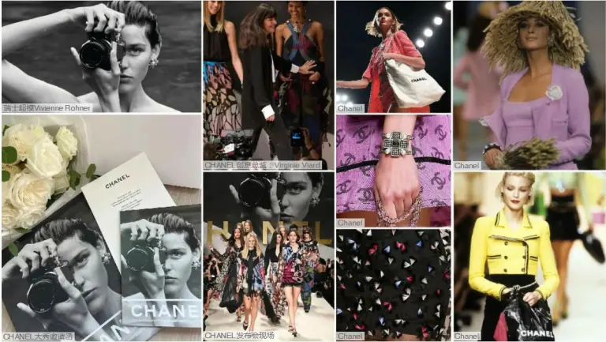

**Importance of Trade Shows**

Trade shows are a great platform to build new connections in the fashion industry. The fashion industry is all about evolution and changing trends, and major trade shows like the Accessories the Show, Magic Show and New York Fashion Week maintain their reputation as being trendsetters in the fashion arena. From introducing innovative manufacturing technologies to new cuts, textures and fabric mixes, trade shows are the virtual launch pads of new fashion trends and therefore, the ideal platform to understand the ebb and flow of the industry.

They provide the perfect opportunity to get an idea of a competitor's activities. This can be highly advantageous to the business as it will give a better idea of what the product will be competing against, how effective the promotional campaigns need to be or the strategies that can earn a competitive advantage in the industry.

Trade shows act as a powerful magnet to many fashion powerhouses and potential clients, and therefore, present a cost-effective means of business marketing.

The fashion industry is inundated with promising designers and apparel producers, and chances are that the brand may be easily forgotten if decide on a no-show. To maintain the mark in the industry, and within the target market, it is essential to get the brand noticed by a continued presence and new offerings at major trade shows.

Small businesses can use trade shows as a platform to spread the word about exciting company news, products and promotions to gain valuable exposure. While a large exhibit may not be in the budget, a smaller 10’ x 10’ exhibit can have a big impact using smart design elements like kiosks, counters and product displays.

Larger companies can make an impact as an industry leader by creating a spacious exhibit that includes powerful design elements like hanging structures, bold graphics and interactive displays.

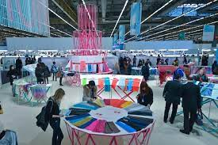 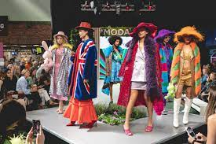

Let us take a look at some of the famous trade shows worldwide :

1. **Dallas Apparel & Accessories Market**

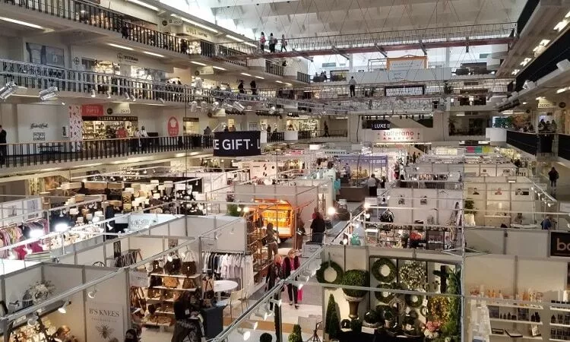

The Dallas Apparel & Accessories Market is a trade show that takes place several times a year in Dallas, Texas. It is a major event in the fashion industry, attracting buyers, sellers, and other industry professionals worldwide.

The market offers a wide selection of clothing and accessories, including apparel, handbags, jewelry, and more. Fashion companies and designers can present their most recent collections to a sizable and varied audience. They can also connect with potential customers and partners at the trade show.

It offers attendees the chance to discover new trends and products and network with other industry professionals. Whether you are a fashion retailer, a designer, or simply someone who loves fashion, the Dallas Apparel & Accessories Market is one of the must-attend fashion trade shows.

**2. Atlanta Apparel** 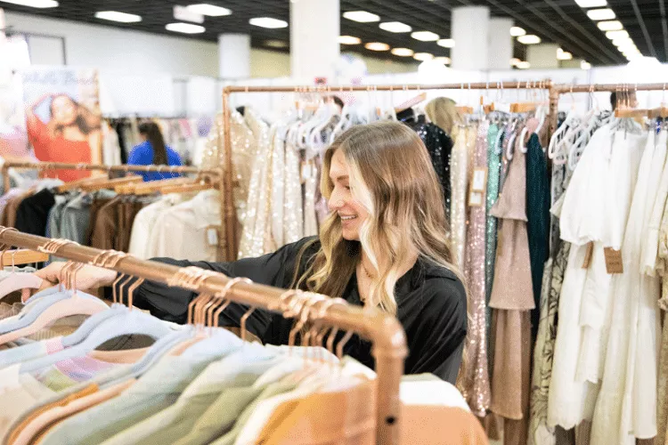

The Atlanta Apparel Trade Show is an annual event that takes place in Atlanta, Georgia. It is a premier event for the fashion industry, attracting many enthusiasts, including retailers, wholesalers, manufacturers, and other professionals.

Among the products at the show are contemporary and young-contemporary fashion lines, as well as specialty categories such as bridal wear, social occasions, children’s clothing, and more.

The Atlanta Apparel Trade Show is the event to attend if you’re looking for a fun and engaging setting where business professionals can learn about the latest trends and goods.

In addition to the main runway event, the show offers a variety of educational opportunities for attendees to learn about current fashion trends.

**3. Winter Bridal Show of West Michigan, 2023**

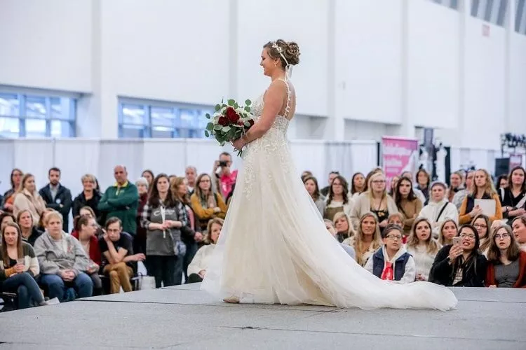

The Winter Bridal Show of West Michigan is an annual event that takes place in Grand Rapids, Michigan. In addition to the thousands of couples and vendors who attend, it attracts business owners, bloggers, and journalists.

The show features various wedding-related products and services, including dresses, tuxedos, invitations, photographers, florists, and more.

It is a chance for wedding industry professionals to display their products and services to thousands of potential customers and connect with other vendors on the same wavelength.

It is a lively, informative event that enables professionals to learn about new products and trends while networking with their peers. Anyone planning a wedding or working in the wedding industry should attend the Winter Bridal Show of West Michigan.

In addition to the main show, this trade show also hosts educational seminars and workshops, giving attendees a chance to learn about new trends in the wedding industry.

The Winter Bridal Show of West Michigan is a premier event for brides and wedding-related businesses, offering attendees an opportunity to learn about the latest field developments.